CS-219 - Computer Engineering Workshop

Complex Engineering Problem (CEP) - Report

Fall Semester 2020







### 

### 

### Group Members:

Sohaib Ahmed Abbasi (CS-19096)

Rohan Ahmed (CS-19091)

Abdul Moiz Ali (CS-19087)

Zain Ammad (CS-19079)

# **Table Of Contents**

**Topic Page Number**

**Project Title** **3**

**Abstract** **3**

**Details** **3**

Launcher Icon and Splash Screen 3

Login Screen 3

Home Screen 5

Pomodoro Timer 5

Todo List 6

Formulas Cheatsheet 7

Wikipedia Search 8

Google Search 8

Useful Links 9

**Program Flow** **10**

## 

## Project Title

Studestant

## Abstract

Studestant, short for Student-Assistant, is an android app aimed to facilitate students, boost their productivity, and improve their focus, by providing various useful features in one place. It has the features of To-do List, Pomodoro Timer, Formulas Cheat-Sheet, Wikipedia Search, Google search, and a collection of useful links. The app secures your data with its user account system which uses Firebase authentication, and it includes options to sign in with Email ID and Google ID. Moreover, it uses Firebase's Cloud Firestore as its cloud storage system.

## **Details**

### Launcher Icon and Splash Screen

This is how our app’s icon looks like in a typical launcher (see image on right).

Tapping on the icon opens up the app where you’re first greeted with the following splash screen (see image below):

### 

### 

### 

### 

### 

### Login Screen

The app uses Firebase for user authentication as well as the login UI. It has the option to sign in with Google ID and email ID. Tapping the Sign in with Google button opens up a menu with a list of accounts already signed in on the device as well as an option to add another account. Tapping the Sign in with email button opens up an input field where you can type in your email ID. If you type in an email ID that isn’t registered with the app, you will be prompted for your name and a new password, if you type in an email ID that is registered with the app you’ll be prompted for your password; and if you type in an email ID that corresponds to a Google ID that has been used to log in to the app before, you will be asked to sign in with that google ID.

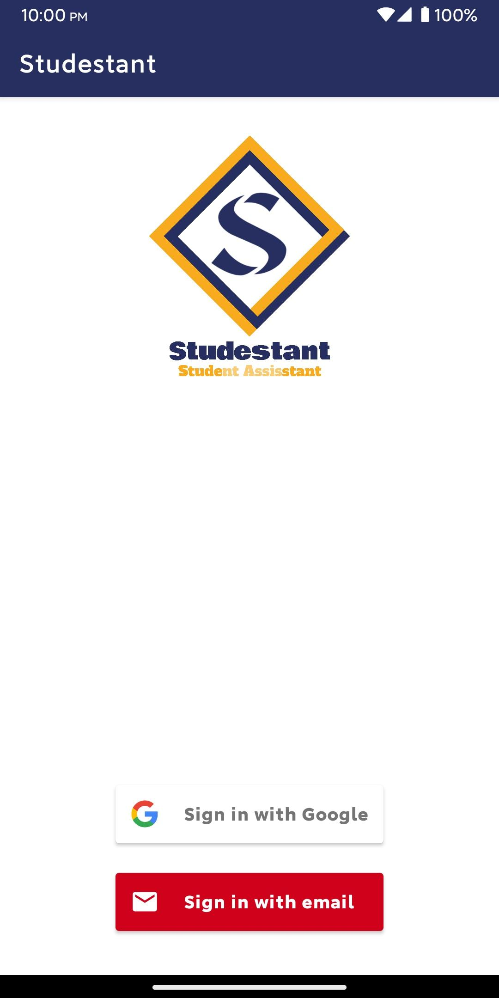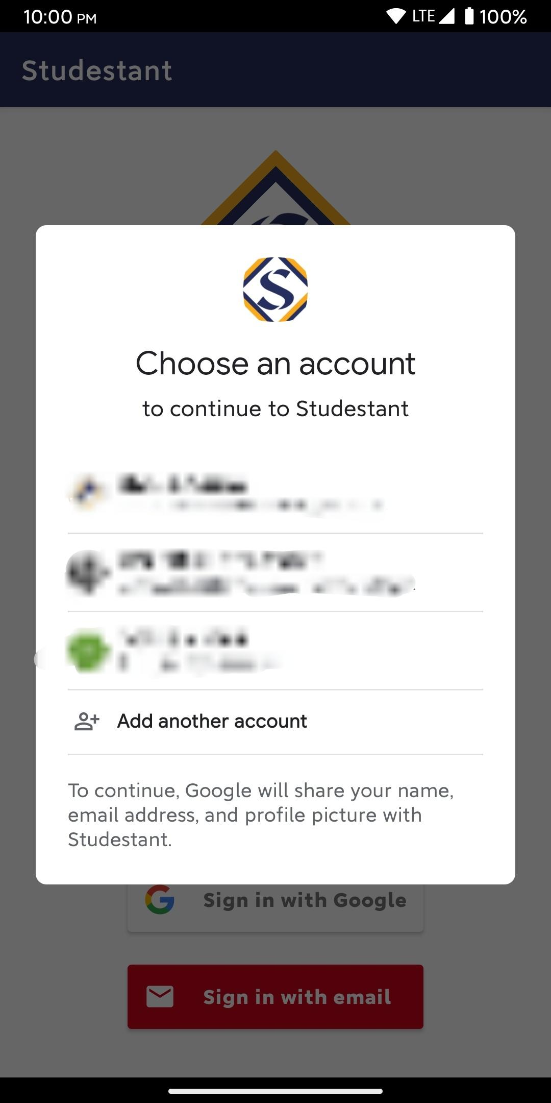

### 

### 

### Home Screen

After logging in, the following home screen opens up (see image on right):

The home screen consists of an options menu in the top right corner which gives you the option to sign out; the app logo; buttons leading to the different features of the app; name and email ID of the signed-in user in the bottom right and a sign out button in the bottom left.

### 

### 

### 

### Pomodoro Timer

This feature helps you to follow the Pomodoro timer which follows the Pomodoro technique which is a technique to improve focus and productivity by having alternate periods of work and rest. It follows the 25-5 pattern of the Pomodoro technique (25 minutes work, 5 minutes rest). First, a screen with details of the Pomodoro timer and how to use it alongside buttons to start work and rest timer is displayed. Tapping the work button starts a 25-minute timer whereas tapping the rest button starts a 5-minute timer; both of these timers end with an alarm sound.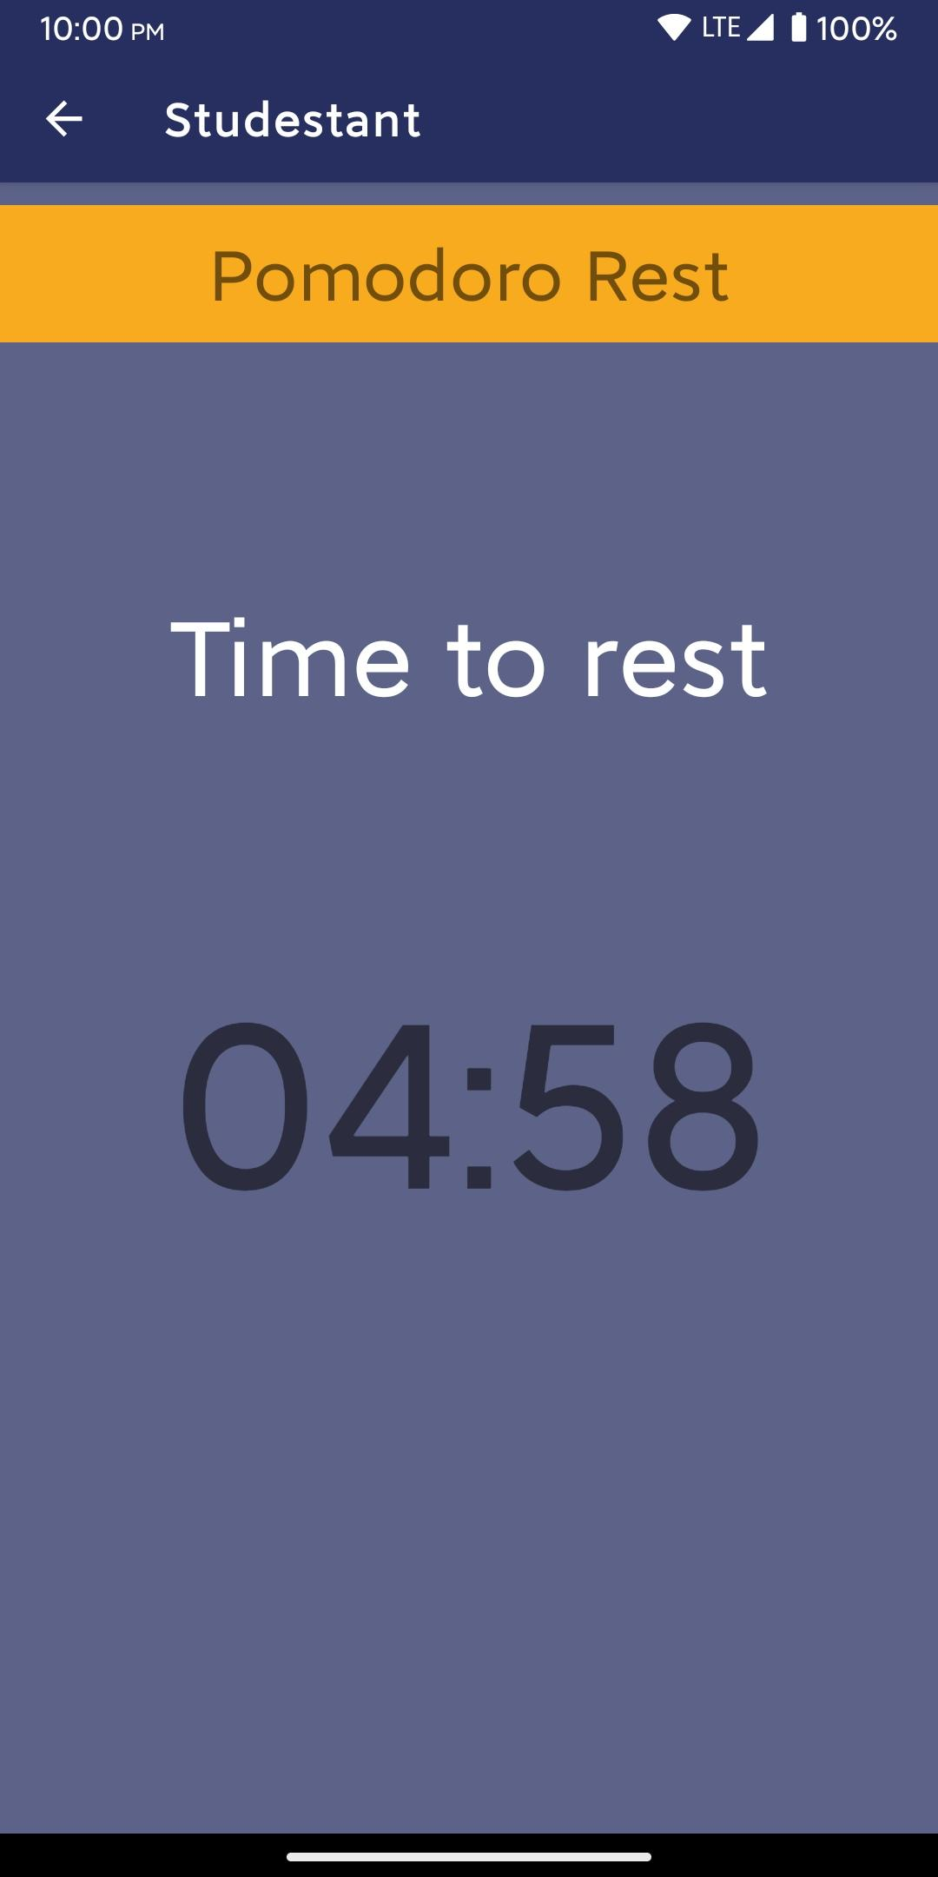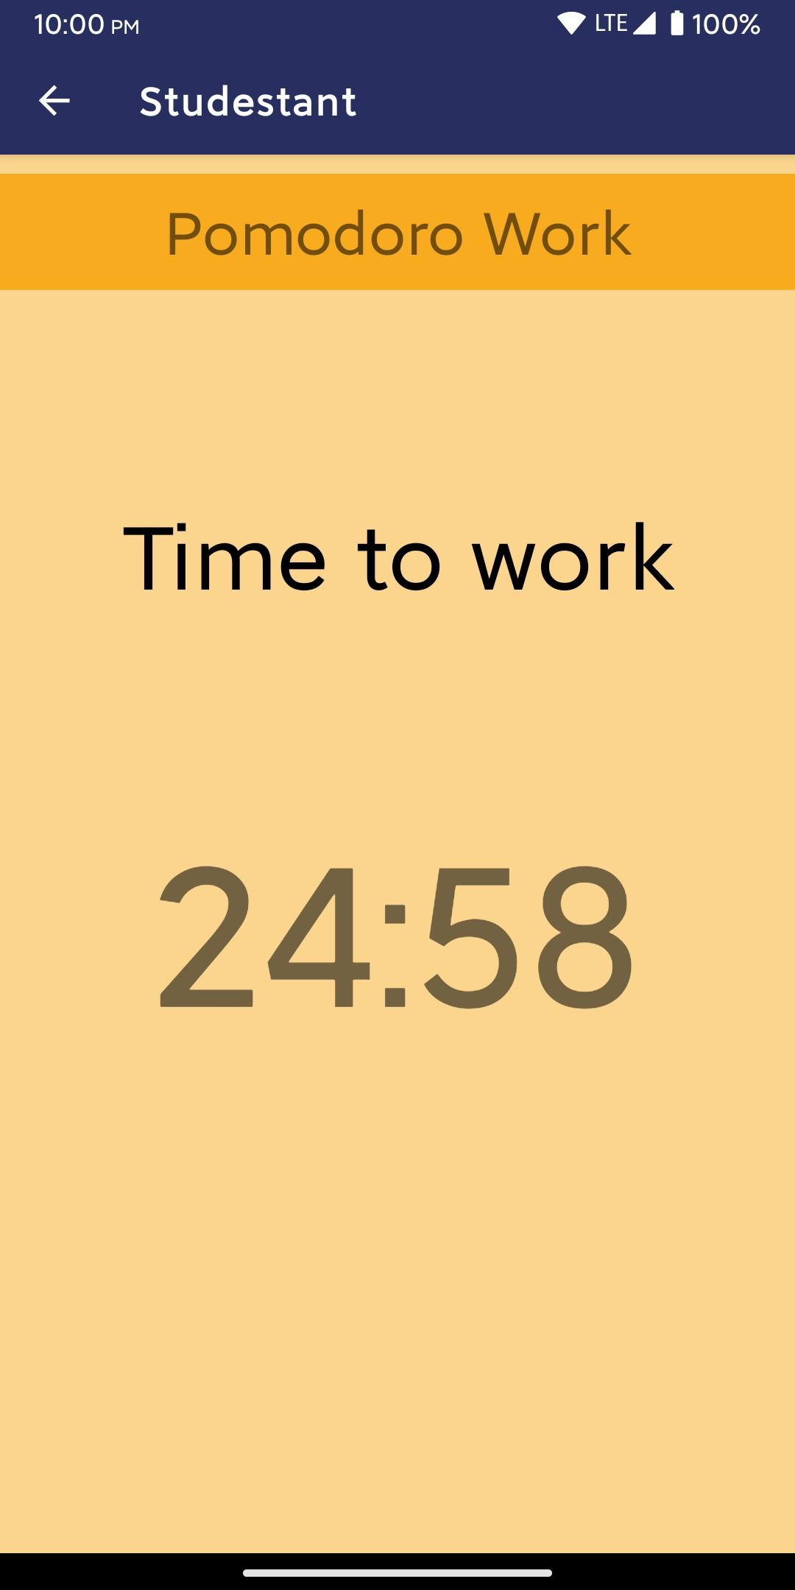

### 

### Todo List

This is to be used to store a list of upcoming tasks that one has to do with optional details of those tasks. It uses the Firestore database to store the information of every user’s to-do items. Tapping the “+” button at the bottom of the screen gives you the option to make a new to-do item with a title and optional details. Tapping on any to-do item opens up a screen where you can see the full to-do item, edit it and delete it. A to-do item can be marked as done or not done by tapping the checkbox on the right of the respective item; marking as done strikethroughs the title and details text.

### 

### 

### 

### Formulas Cheatsheet

This part of the app features a bunch of formulas categorized under basic formulas, trigonometric formulas, and physics formulas that you can quickly lookup. It has a screen with buttons that lead you to screens having the respective formula categories.

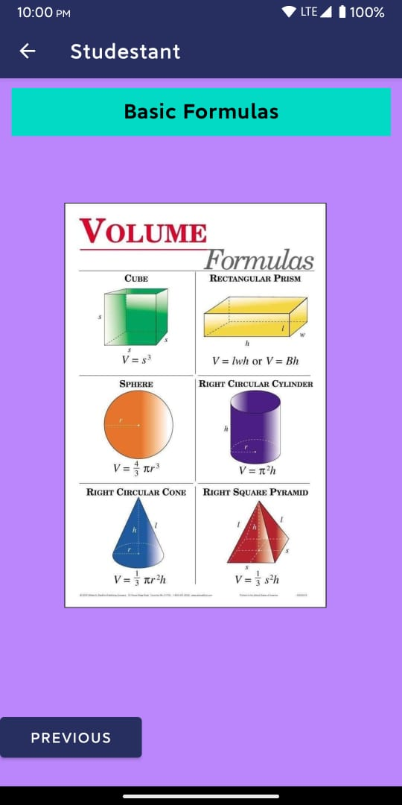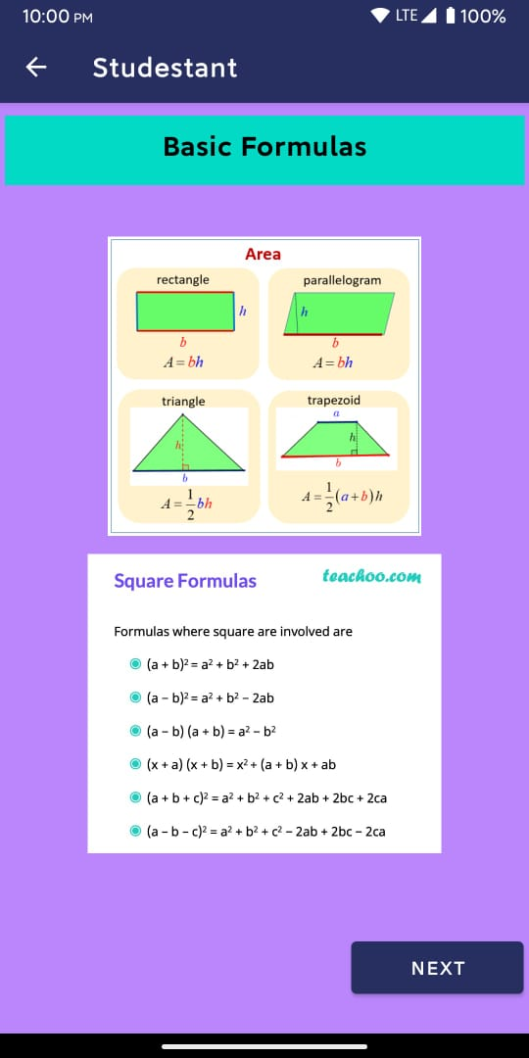

### 

### 

### Wikipedia Search

This feature can be used to open up any Wikipedia page you want. It has an input field where you can type the name of the Wikipedia page you want to go to and a button that can be tapped to open up the page you want to go in your mobile’s browser. The reason for having this feature in the app is to prevent the user from going into their browser and searching for the Wikipedia page they want because that can easily lead to the user falling to the temptation of going to some other time-wasting / non-productive website or application.

### 

### 

### Google Search

Very similar to the Wikipedia search feature, this feature has a similar purpose and functionality. It can be used to type in and open up the google search page of any thing you want to look up. It can particularly be useful to search up specific definitions, formulas, etc.

### 

### Useful Links

The useful links section of the app contains a list of links that students may not know about but can be quite useful. Each link can be opened up by clicking its respective “Click here” text.

*(Program flow on next page)*

## Program Flow

